RESUME
Gaurav Kumar
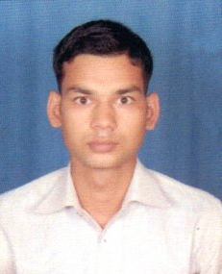
S/O Mr. Vasudev Singh
Vill : Apraula
Post : Khera
Distt : Amroha(U.P.)
India 244251
Mob. : +91 9012569305
Email : gaurav13815@gmail.com

Career Objective:
Interested in Engineering. Ensure Meeting agreed objective of standard efficiency. Maintain high moral of work force, ensure compliance of all procedures and rules of the organization.

Experience:
- Fresher

Specialization:
- Civil Engineering

Education:
- I have completed my Four Year Degree B. Tech. with Civil Engineering from Amani Group of Institutions Bijnor Road Amroha affiliated from AKTU in 2017 with first division .
- I have completed my Intermediate with PCM from Ramesh Chandra Inter College Naseer Nagla affiliated from U.P. Board in 2013 with first division.
- I have completed my Metric Exam with Science from Janta HSS Takhatpur J P Nagar affiliated from U.P. Board in 2011 with first division.

Summer Training:
- Thirty Days Summer Training in PWD Joya Road Amroha.

Strength:-
- Never say Die approach, Tries for perfection in every time.
- Working in every field with Devotion & Honesty.
- Adaptable to any kind of environment and can work under pressure.
- Good analytical and communication skills.

Language Known:
- Hindi
- English

Personal Profile:
Father’s Name : Mr. Vasudev Singh
Height : 172cm.
Weight : 65Kg.
Blood Group : Unknown
Religion : Hindu
Nationality : Indian

Declaration:-
I am keen to continue my career and prepared to work hard in order to achieve my organization objectives and I hereby declare that the information furnished above is true to the best of my knowledge.

Dated:
Place:

(Gaurav Kumar)

